|  |  |
| --- | --- |
| **TITLE** | Write a simple program in SCALA using Apache Spark framework. |
| **PROBLEM STATEMENT/ DEFINITION** | Implement bubble/quick sort Algorithm using scala programming |
| **OBJECTIVE** | 1) Big Data Analysis with Apache Spark. |
| **S/W PACKAGES AND HARDWARE APPARATUS USED** | scala-2.11.7.deb  oracle-java7-installer |
| **REFERENCES** | 1) https://www.analyticsvidhya.com/blog/2017/01/scala/ |
| **STEPS** | **Refer to student activity flow chart if found necessary by subject teacher and relevant to the subject**  **manual.**  **Describe steps only.** |
| **INSTRUCTIONS FOR WRITING JOURNAL** | 1. title 2. Problem statement 3. Learning objective 4. Learning outcome 5. Theory (includes methods, libraries and functions, 6. Analysis (as per assignment), 7. conclusion. |

HeadofDepartment SubjectCo-ordinator

**(Dr. M.S.Takalikar) (Dr. S.S.Sonawane)**

P:F:-LTL-UG / 03 /R1

1. Title:-

Write a simple program in SCALA using Apache Spark framework.

2. Problem statement :

Implement Bubble/Quick sort Algorithm using scala programming

3. Learning objective :

Big Data Analysis with Apache Spark.

4. Learning outcome:

Students can able to write the scala program using object oriented features.

5. Theory:

1) Installing Scala

Scala can be installed in any Unix or windows based system. Below are the steps to install for Ubuntu (14.04) for scala version 2.11.7. I am showing the steps for installing Scala (2.11.7) with Java version 7. It is necessary to install Java before installing Scala. You can also install latest version of Scala(2.12.1) as well.

Step 0: Open the terminal

Step 1: Install Java

$ sudo apt-add-repository ppa:webupd8team/java

$ sudo apt-get update

$ sudo apt-get install oracle-java7-installer

If you are asked to accept Java license terms, click on “Yes” and proceed. Once finished, let us check whether Java has installed successfully or not. To check the Java version and installation, you can type:

$ java -version

Step 2: Once Java is installed, we need to install Scala

$ cd ~/Downloads

$ wget http://www.scala-lang.org/files/archive/scala-2.11.7.deb

$ sudo dpkg -i scala-2.11.7.deb

$ scala –version

This will show you the version of Scala installed

 2. Prerequisites for Learning Scala

Scala being an easy to learn language has minimal prerequisites. If you are someone with basic knowledge of C/C++, then you will be easily able to get started with Scala. Since Scala is developed on top of Java. Basic programming function in Scala is similar to Java. So, if you have some basic knowledge of Java syntax and OOPs concept, it would be helpful for you to work in Scala.

Warming up: Running your first Scala program in Shell:  
Let’s write a first program which adds two numbers.

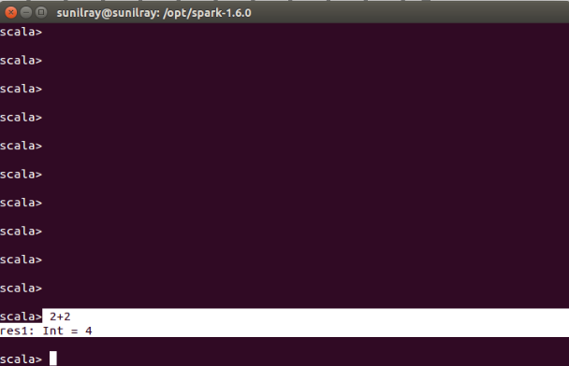

 3. Things to note about Scala

* It is case sensitive
* If you are writing a program in Scala, you should save this program using “.scala”
* Scala execution starts from main() methods
* Any identifier name cannot begin with numbers. For example, variable name “123salary” is invalid.
* You can not use Scala reserved keywords for variable declarations or constant or any identifiers.

4. Variable declaration in Scala

In Scala, you can declare a variable using ‘var’ or ‘val’ keyword. The decision is based on whether it is a constant or a variable. If you use ‘var’ keyword, you define a variable as mutable variable. On the other hand, if you use ‘val’, you define it as immutable. Let’s first declare a variable using “var” and then using “val”.

4.1 Declare using var

var Var1 : String = "Ankit"

In the above Scala statement, you declare a mutable variable called “Var1” which takes a string value. You can also write the above statement without specifying the type of variable. Scala will automatically identify it. For example:

var Var1 = "Gupta"

 4.2 Declare using val

val Var2 : String = "Ankit"

In the above Scala statement, we have declared an immutable variable “Var2” which takes a string “Ankit”. Try it for without specifying the type of variable. If you want to read about mutable and immutable please refer this [link](http://stackoverflow.com/questions/8287425/mutable-vs-immutable-in-scala-collections).

5. Operations on variables

You can perform various operations on variables. There are various kinds of operators defined in Scala. For example: Arithmetic Operators, Relational Operators, Logical Operators, Bitwise Operators, Assignment Operators.

Lets see “+” , “==” operators on two variables ‘Var4’, “Var5”. But, before that, let us first assign values to “Var4” and “Var5”.

scala> var Var4 = 2

Output: Var4: Int = 2

scala> var Var5 = 3

Output: Var5: Int = 3

Now, let us apply some operations using operators in Scala.

Apply ‘+’ operator

Var4+Var5

Output:

res1: Int = 5

**Apply “==” operator**

Var4==Var5

Output:

res2: Boolean = false

If you want to know complete list of operators in Scala refer this [link](https://www.tutorialspoint.com/scala/scala_operators.htm):

 6. The if-else expression in Scala

In Scala, if-else expression is used for conditional statements. You can write one or more conditions inside “if”.  Let’s declare a variable called “Var3” with a value 1 and then compare “Var3” using if-else expression.

var Var3 =1

if (Var3 ==1){

println("True")}else{

println("False")}

Output: True

In the above snippet, the condition evaluates to True and hence True will be printed in the output.

7. Iteration in Scala

Like most languages, Scala also has a FOR-loop which is the most widely used method for iteration. It has a simple syntax too.

for( a <- 1 to 10){

println( "Value of a: " + a );

}

Output:

Value of a: 1

Value of a: 2

Value of a: 3

Value of a: 4

Value of a: 5

Value of a: 6

Value of a: 7

Value of a: 8

Value of a: 9

Value of a: 10

Scala also supports “while” and “do while” loops. If you want to know how both work, please refer this [link](https://www.tutorialspoint.com/scala/scala_loop_types.htm).

 8. Declare a simple function in Scala and call it by passing value

You can define a function in Scala using “def” keyword. Let’s define a function called “mul2” which will take a number and multiply it by 10. You need to define the return type of function, if a function not returning any value you should use the “Unit” keyword.

In the below example, the function returns an integer value. Let’s define the function “mul2”:

def mul2(m: Int): Int = m * 10

Output: mul2: (m: Int)Int

Now let’s pass a value 2 into mul2

mul2(2)

Output:

res9: Int = 20

6. Analysis (as per assignment),

7. conclusion:- Hence students can able to understand the basic concept of scala program using

apache spark framework.